- What is the average number of orders per customer? Are there high-value repeat customers?
Answer:
with cte as(
select CustomerID,count(o.OrderID) as order_count, sum(unitprice*quantity) as revenue
from orders o
join order_details od
on o.OrderID = od.OrderID
group by customerID)
select * from cte
order by order_count desc, revenue desc;
output:
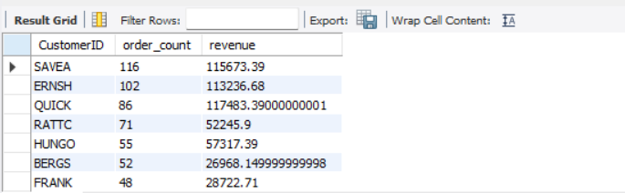

2. How do customer order patterns vary by city or country?
Answer:
with cte as(
select ShipCountry,ShipCity,count(OrderID),
rank() over(partition by ShipCountry order by count(OrderID) desc) as country_rank
from orders
group by ShipCountry,ShipCity
order by count(OrderID) desc)
select * from cte
where country_rank=1

output:

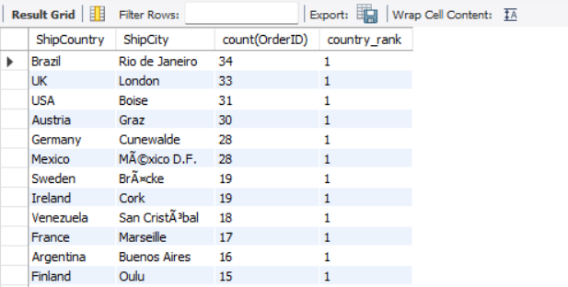
- Can we cluster customers based on total spend, order count, and preferred categories?
Answer
with cte as(
select o.CustomerID,o.OrderID,(od.UnitPrice*od.Quantity) as Total_amount,CategoryName
from orders o
join order_details od
on o.OrderID=od.OrderID
join products p
on od.ProductID=p.ProductID
join categories c
on p.CategoryID=c.CategoryID
)
select CategoryName,round(sum(Total_amount),2) as revenue
from cte
group by categoryname
order by revenue desc
limit 3
Output:
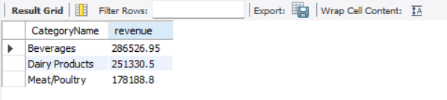
4. Which product categories or products contribute most to order revenue? 5 .Are there any correlations between orders and customer location or product category?
Answer:
select ShipCountry,ShipCity,sum(Quantity) as Total_quantity
from orders o
join order_details od
on o.OrderID=od.OrderID
group by ShipCountry,ShipCity;

Output:
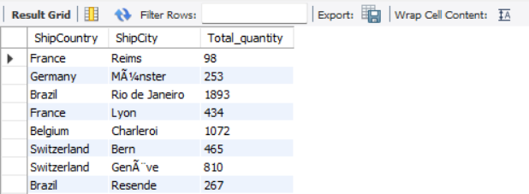
- How frequently do different customer segments place orders?
Answer:
with cte as(
select CustomerID,OrderDate,
lead(OrderDate) over(partition by CustomerID order by OrderDate desc) as next_order
from orders)
select *,datediff(OrderDate,next_order) as datediff
from cte
Output:
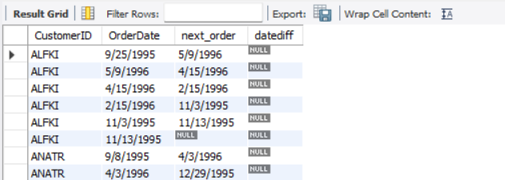
- What is the geographic and title-wise distribution of employees?
Answer:
Select Country,Title,count(Title) from employess
group by Country,Title;
Output:
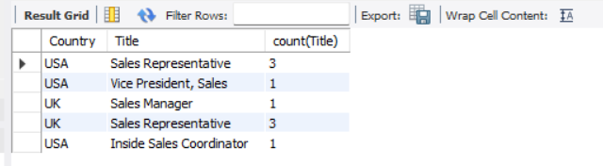
- What trends can we observe in hire dates across employee titles?
Answer:
select year(HireDate) as hired_year,Title,count(Title)
from employess
group by hired_year,Title;
Output:
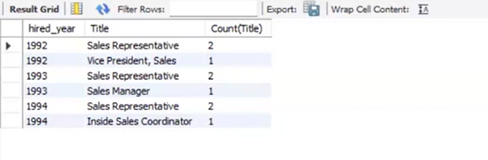
- What patterns exist in employee title and courtesy title distributions?
Answer:
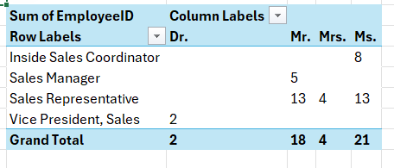
Output:
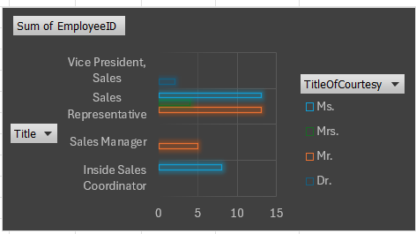
9. Are there correlations between product pricing, stock levels, and sales performance?
Answer:
select p.ProductID,p.ProductName,p.UnitPrice,p.UnitsInStock,p.UnitsOnOrder,
sum(od.Quantity) total_unit_sold,round(sum(p.UnitPrice*od.Quantity),2) revenue
from products p
join order_details od
on p.ProductID=od.ProductID
group by p.ProductID,p.ProductName,p.UnitPrice,p.UnitsInStock,p.UnitsOnOrder
order by total_unit_sold desc,revenue desc;
Output:
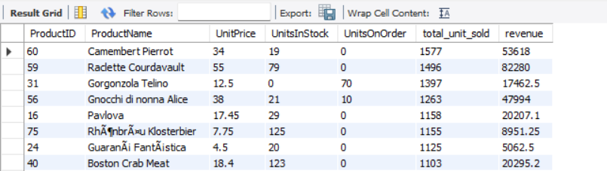
10. How does product demand change over months or seasons?
Answer:
select
date_format(OrderDate,'%Y-%m') as month,
c.categoryName,sum(Quantity)
from orders o
join order_details od
on o.OrderID=od.OrderID
join products p
on od.ProductID=p.ProductID
join categories c
on p.CategoryID=c.CategoryID
group by month,c.CategoryName
order by month
Output:
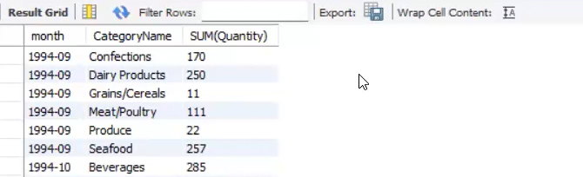
11. Can we identify anomalies in product sales or revenue performance?
Answer:
with cte as(select
date_format(OrderDate,'%Y-%m') as month,
sum(Quantity*p.UnitPrice) revenue
from orders o
join order_details od
on o.OrderID=od.OrderID
join products p
on od.ProductID=p.ProductID
group by month)
select month,round(revenue,2),
round(lag(revenue) over(Order by month),2) as Prev_month_revenue,
round((revenue - lag(revenue) over(order by month))*100/lag(revenue) over(order by month),2) as growth_rate
from cte;Output:
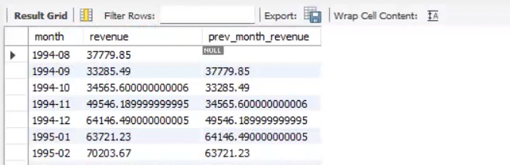
12. Are there any regional trends in supplier distribution and pricing?
Answer:
SELECT s.country,
AVG(p.UnitPrice) AS avg_price,
MIN(p.UnitPrice) AS min_price,
MAX(p.UnitPrice) AS max_price
FROM suppliers s
JOIN products p
ON s.SupplierID = p.SupplierID
GROUP BY s.country
ORDER BY avg_price;

Output:
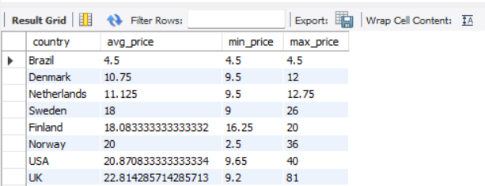

13. How are suppliers distributed across different product categories?
Answer:
SELECT
c.CategoryName,COUNT(DISTINCT p.SupplierID) AS supplier_count
FROM categories c
JOIN products p
ON c.CategoryID = p.CategoryID
GROUP BY c.CategoryName
ORDER BY supplier_count DESC;
Output:
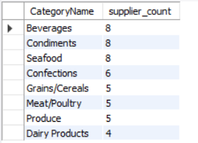

14. How do supplier pricing and categories relate across different regions?
Answer:
SELECT
s.country,
c.CategoryName,
AVG(p.UnitPrice) AS avg_price,
COUNT(DISTINCT s.SupplierID) AS supplier_count
FROM suppliers s
JOIN products p
ON s.SupplierID = p.SupplierID
JOIN categories c
ON p.CategoryID = c.CategoryID
GROUP BY s.country, c.CategoryName
ORDER BY s.country, c.CategoryName;
Output:
